Archer GRC Tool- Approve/Reject the Assessment

Once the Risk Assessment is submitted, a person who performs a role of HIPAA Working Group Member -HWGM/Reviewer will get an auto generated email from Archer tool saying that a new assessment is available for the review.
To start the review, HWGM/Reviewer can either click the link in the email to be taken directly to the assessment within Archer tool or can login to Archer tool itself and see outstanding assessments on the main tab- Compliance To Do List.

The outstanding assessment list can look similar to the screenshot below. To start the assessment, click on the Assessment Link hyperlink.

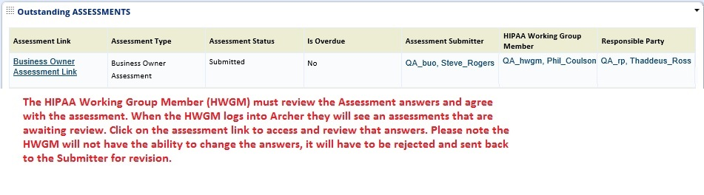

HWGM/Reviewer will review the answers for accuracy. If there is an answer HWGM/Reviewer does not agree with, he/she can add a note by clicking the notepad icon and adding notes as to why the answer is not considered accurate. HWGM/Reviewer does not have ability to change the answers.

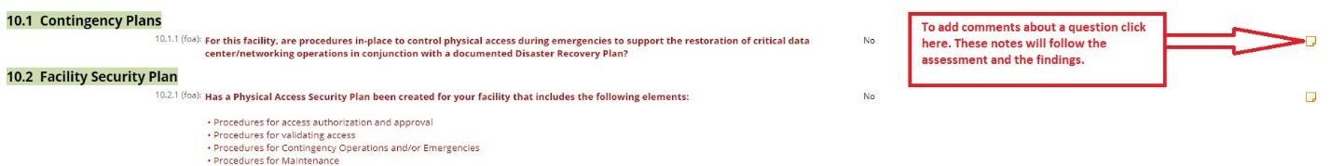

Once all the answers are reviewed, HWGM/Reviewer will select either Reject or Approve button. If there are answers which need to be corrected, the risk assessment needs to be Rejected. HWGM/Reviewer should enter the reason for rejecting the Assessment in the “Reason(s) for Rejected Review” field/box at the bottom of the assessment form.

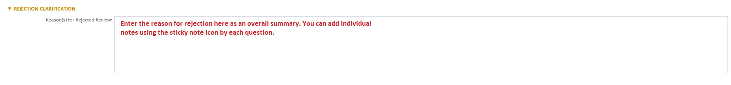

If all the answers look correct, then the assessment needs to be Approved.

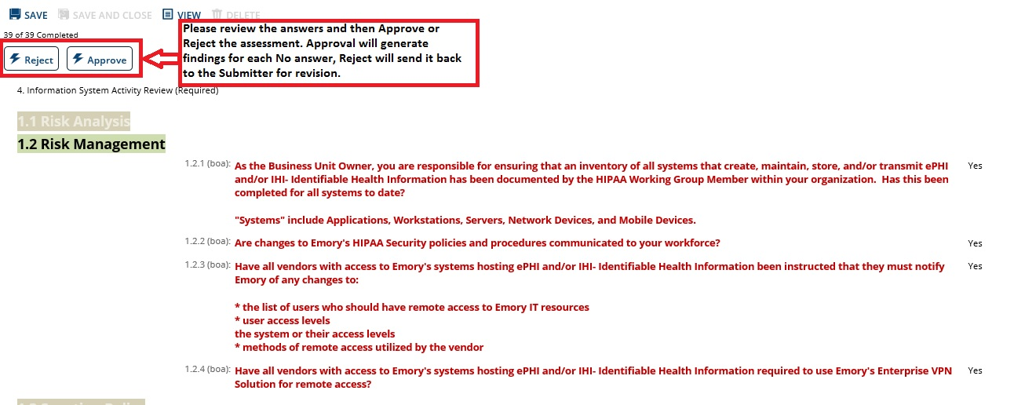
Once the assessment is Rejected or Approved, HWGM/Reviewer will no longer see this assessment listed in the Outstanding Assessment dashboard on the Compliance To Do List tab, but both HWGM/Reviewer and Assessment Submitter will still see it in the All Available Assessment dashboard on the Compliance Overview tab in the Rejected or Approved status.

If the assessment is Rejected, the Assessment Submitter will see the assessment back in the Outstanding Assessment dashboard on the Compliance To Do List.

The Assessment Submitter will also receive auto generate email, stating that the assessment was either Rejected or Approved.

