Archer GRC Tool- Create Remediation Plans for one or multiple findings
Once all findings have an appropriate owner, a plan to address each finding needs to be created. In some cases, one remediation plan can address multiple findings.

Start by locating the finding- you can access the findings from the Outstanding Findings dashboard on the Compliance To Do List tab, click on the name of the findings to open it up.

Findings are tracked to completion by using Remediation Plans. You must create a Remediation Plan for each Find, or you can add multiple Finding to a single Remediation Plan.

Scroll down in the Finding to the Remediation Plan section. This section will not appear until you have clicked on the Remediate Risk button in the prior steps.

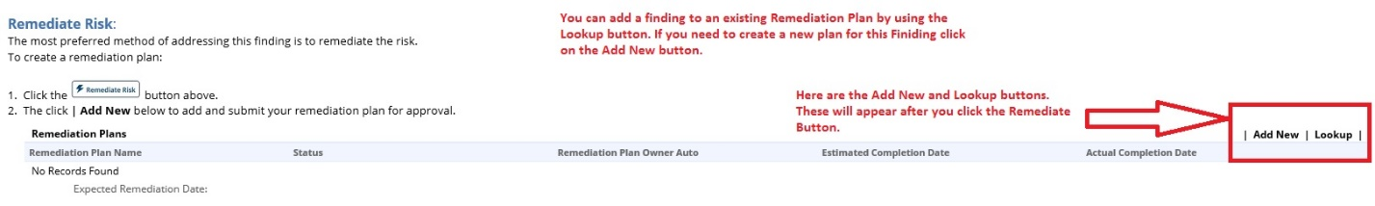

Once you click Add New you will see the screen below.

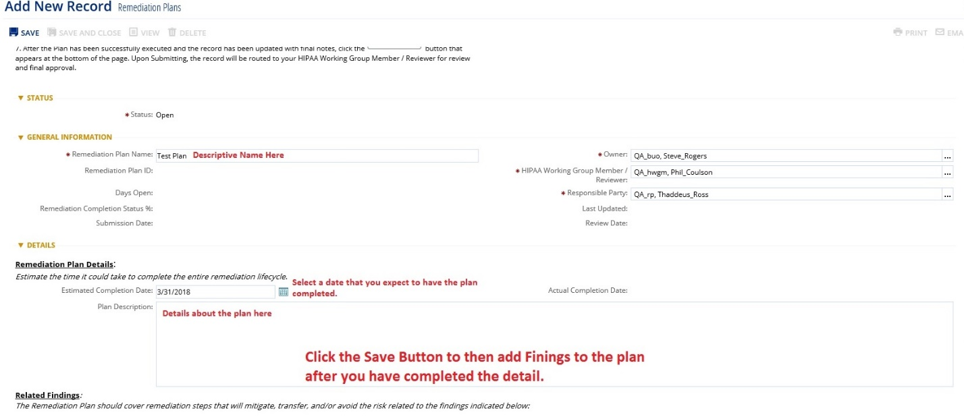
Once you enter all the details, click SAVE button, then click the SUBMIT for REVIEW button. The newly created Remediation Plan will be sent to HWGM/Reviewer for Approval.

Add Multiple Findings to One Remediation Plan

To address multiple findings with one remediation plan, its best to create a Remediation Plan first and then locate, select and add multiple finding to the remediation plan.

To access the Remediation plans- Click on the arrow next to Compliance To Do List, then Issue Management, then Remediation Plans. As shown below.
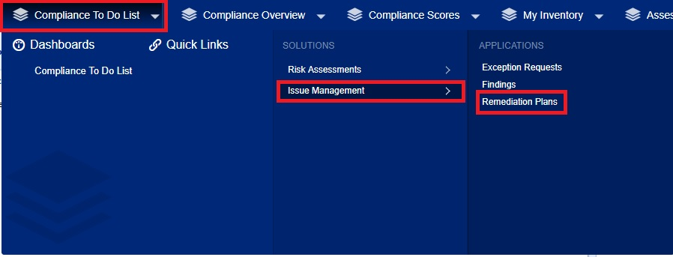

Create a new Remediation Plan by clicking the New Record button
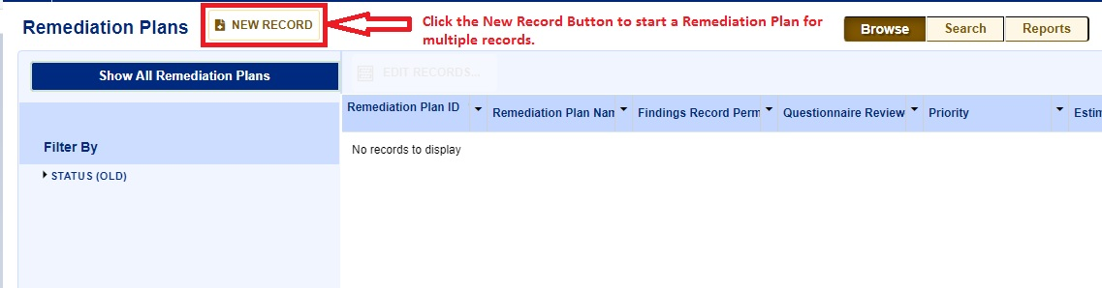

Once the New Record opens up, give the Remediation Plan a descriptive name, set up Submission date, Estimated Completion date and list the remediation steps to be completed.

Estimated Completion date is the date when the remediation is expected to be done by. It is also required to select the Owner, HWGM, and the Responsible Party.

Click the SAVE button to save the Remediation Plan and continue to add findings to it. Once you have clicked SAVE, two more options will appear-the Submit For Review button and the Lookup button.
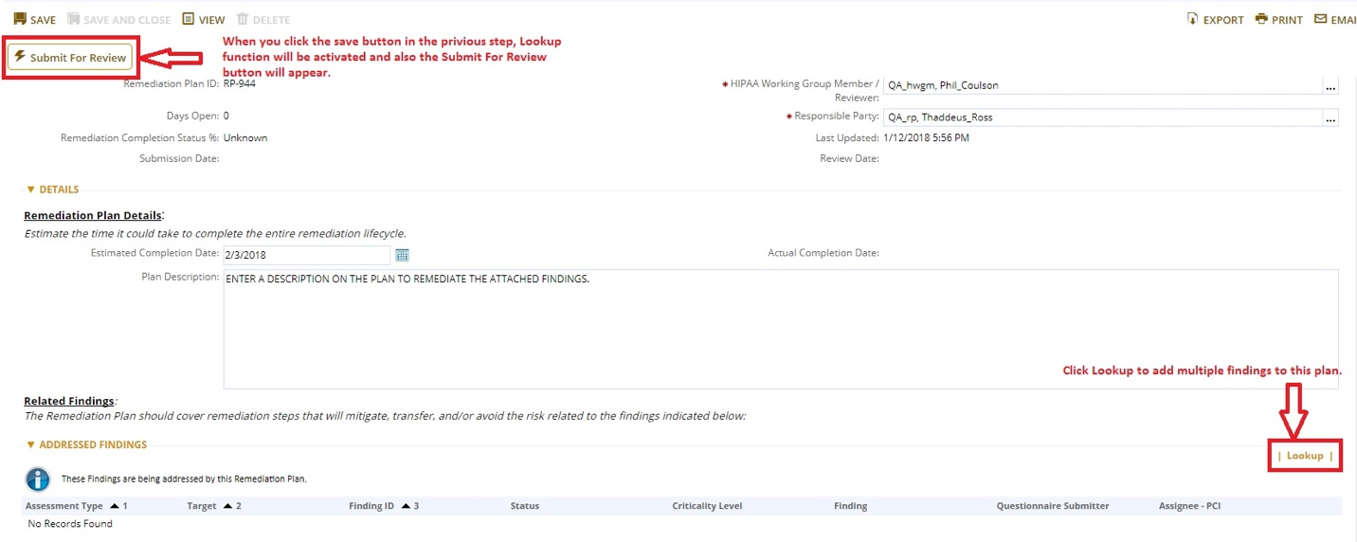
Use the Lookup button to located the findings you want to associate with this remediation plan.

Check the box next to each Finding you want to add to the Remediation Plan and click the OK button.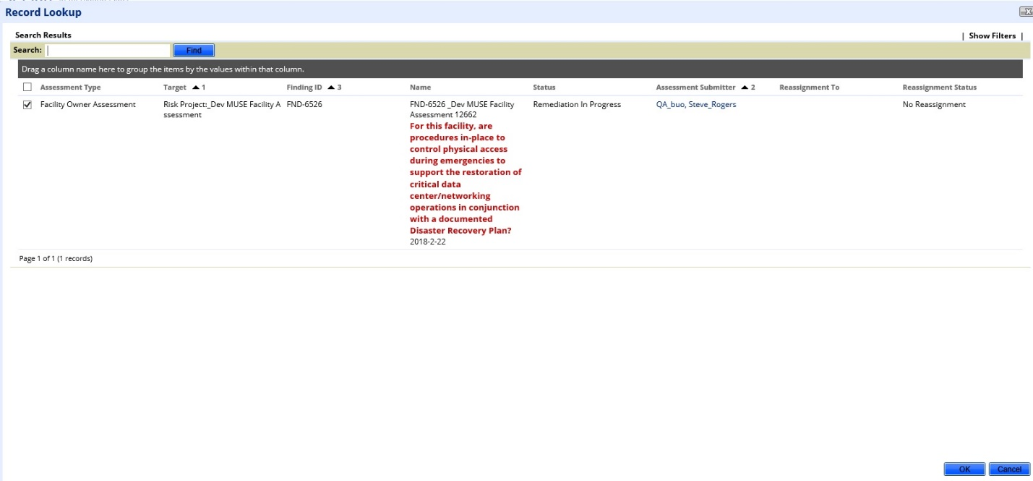

Once all findings are added, click the Submit For Review button.

Once submitted the HWGM/Reviewer will need to agree with the plan and then click on Approve.

