Archer GRC Tool- Review Exception Requests

Exception requests go through 2 step approvals. First level of approvals is done by a person who performs the role of HIPAA Working Group Member -HWGM/Reviewer.

Once Exception Request is submitted, HWGM/Reviewer will get an auto generated email from Archer tool saying that a new exception request is available for the review.
To start the review, HWGM/Reviewer can either click the link in the email to be taken directly to the request within Archer tool or can login to Archer tool itself and see outstanding Exception Requests on the main tab- Compliance To Do List.

The outstanding Exception Requests list can look similar to the screenshot below

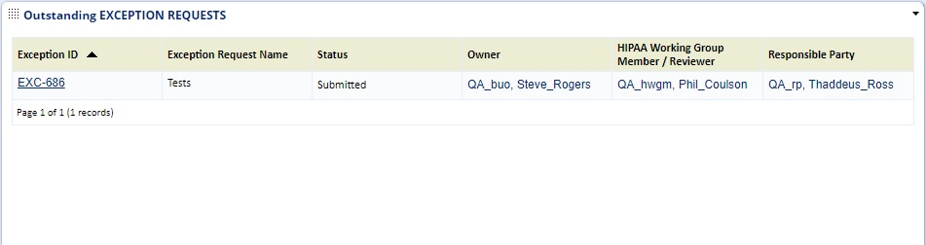

HWGM/Reviewer will review the Exception Request for accuracy. If HWGM/Reviewer does not agree with the request, he/she can add a reason as to why the exception is not appropriate in this case in the “Reason for Rejection” box under the “Rejection Clarification” section. Once the exception is reviewed, HWGM/Reviewer will select either Reject or Approve button. If the Exception Request is not appropriate and a remediation plan needs to be created instead, the Exception Request needs to be Rejected. If the Exception Request is appropriate, then request needs to be Approved.
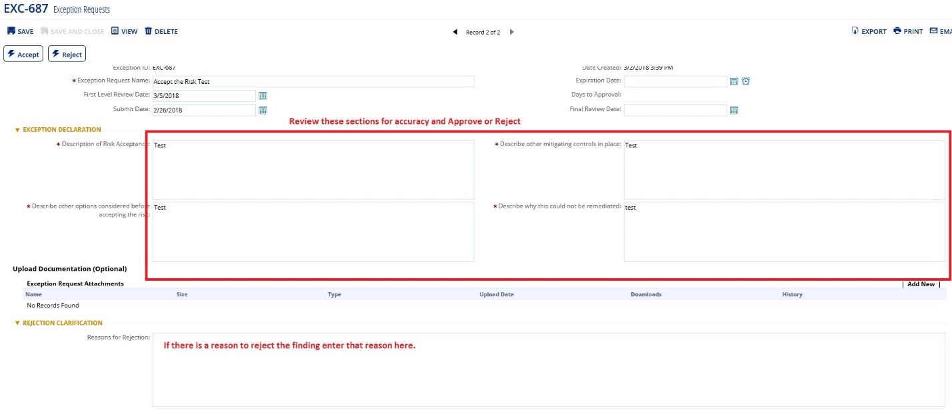

2nd level approval is done by a person who performs the role of Responsible Party

Once Exception Request is approved by HWGM/Reviewer, Responsible Party will get an auto generated email from Archer tool saying that a new exception request is available for the review.
To start the review, Responsible Party can either click the link in the email to be taken directly to the request within Archer tool or can login to Archer tool itself and see outstanding Exception Requests on the main tab- Compliance To Do List.

The outstanding Exception Requests list can look similar to the screenshot below

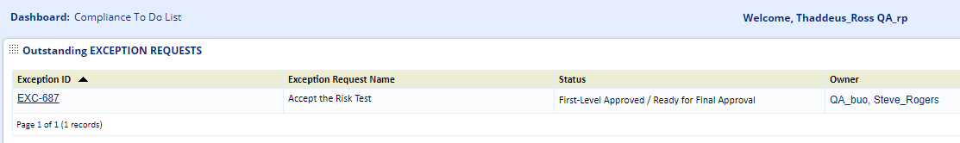

Responsible Party will review the Exception Request for accuracy. If Responsible Party does not agree with the request, he/she can add a reason in the “Reason for Rejection” box under the “Rejection Clarification” section as to why the exception is not appropriate in this case. Responsible Party does not have ability to change the answers.

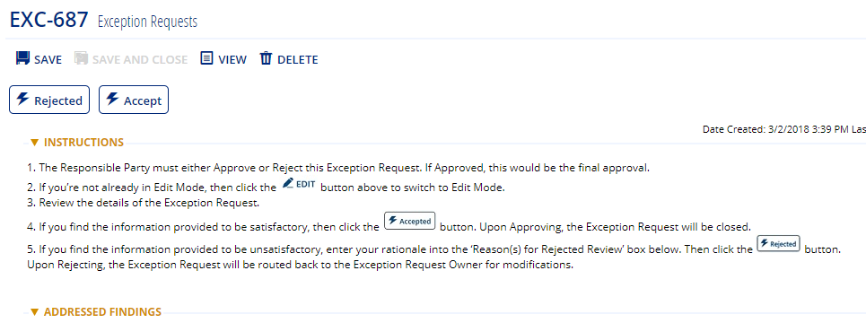

Once the exception is reviewed, Responsible Party will select either Reject or Approve button. If the Exception Request is not appropriate and a remediation plan needs to be created instead, the Exception Request needs to be Rejected. If the Exception Request is appropriate, then request needs to be Approved.

All Exception Requests need to be reviewed periodically according to the Emory Enterprise HIPAA Security Policies.

