Archer GRC Tool- Assign New Owner to Findings
Once HWGM/Reviewer Approves the risk assessment, each No answer will be converted to a finding. By default, the Assessment Submitter is the owner of the finding and is responsible for remediation of the finding.

Generated findings will appear in Outstanding Findings dashboard on the Compliance To Do List tab for the Assessment Submitter.

If the Assessment Submitter is not the appropriate person to work on this finding, the ownership can be manually re-assigned to another user within Archer.

To Re-assign the finding open the Finding record and click on the Re-Assign button.
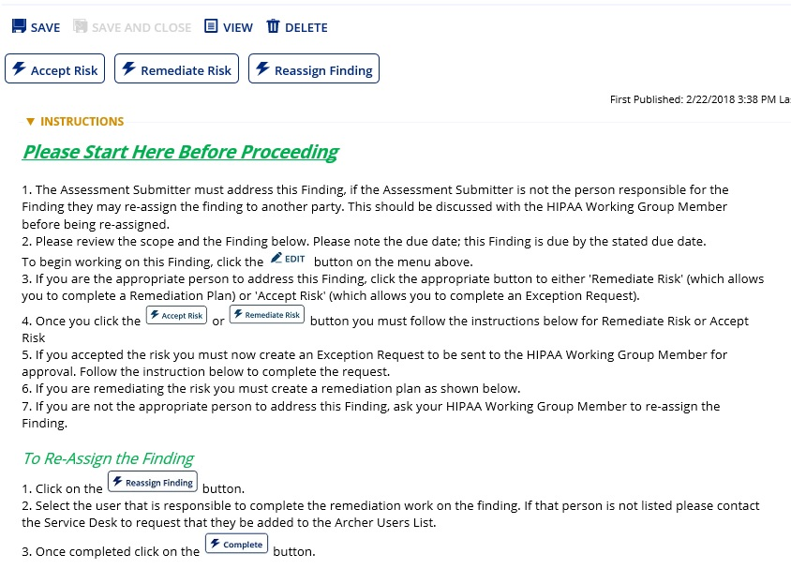

Click on the ellipsis button to select the user who is responsible for remediating the finding. Then click Complete to save the record. That user will be notified by email that they have a Finding in Archer. The finding should only be re-assigned with the prior approval of both the user and the HWGM.
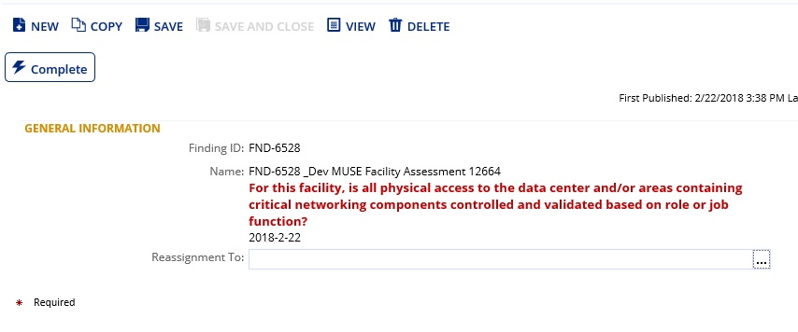

Assessment Submitter or HWGM can manually reassign the findings owner.

