Archer GRC Tool- Complete the Assessment
When a new risk assessment is activated in Archer, a user who performs the role of Assessment Submitter will get notified via email that a new assessment is available.

To start the risk assessment, Assessment Submitter can either click the link in the email to be taken directly to the assessment within Archer tool or can login to Archer tool itself and see outstanding assessments on the main tab- Compliance To Do List.

The outstanding assessment list can look similar to the screenshot below. To start the assessment, click on the Assessment Link hyperlink.
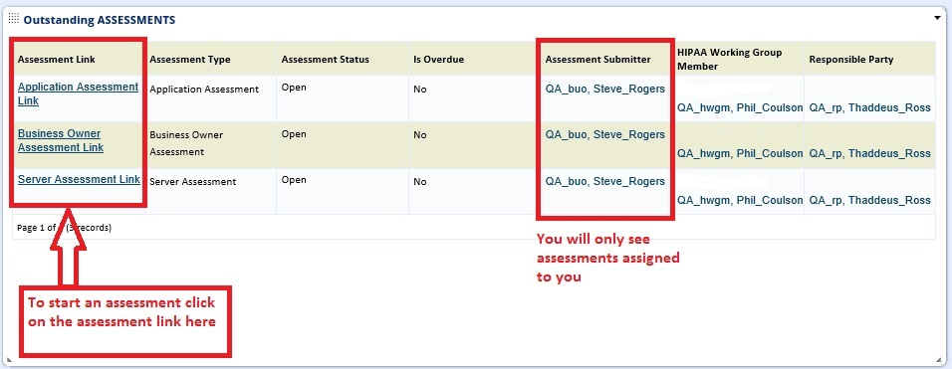

Following the link in email or clicking the hyperlink on the Compliance To Do List tab will take you inside the Risk Assessment. From there you can follow the instructions which are embedded in the risk assessment itself.

To start the Risk Assessment- Click on the EDIT button, this will put the record in Edit mode and will allow you to answer the questions.
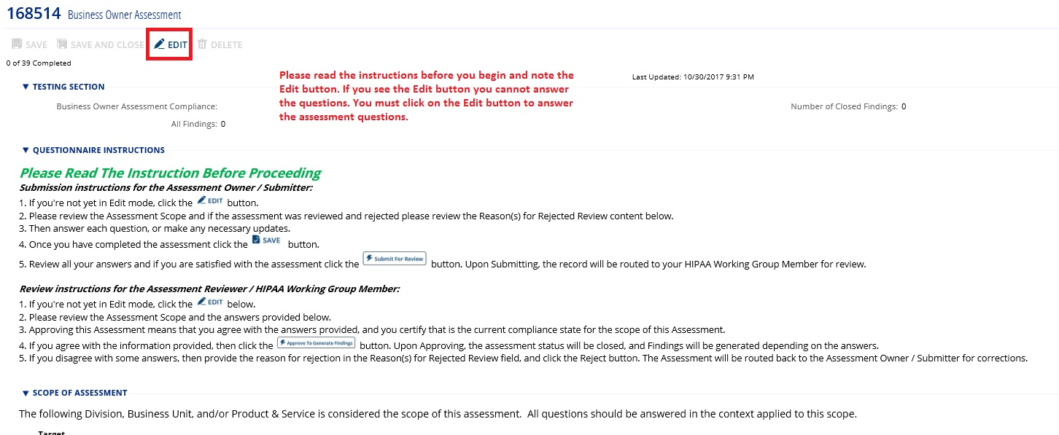

Answer all the questions:
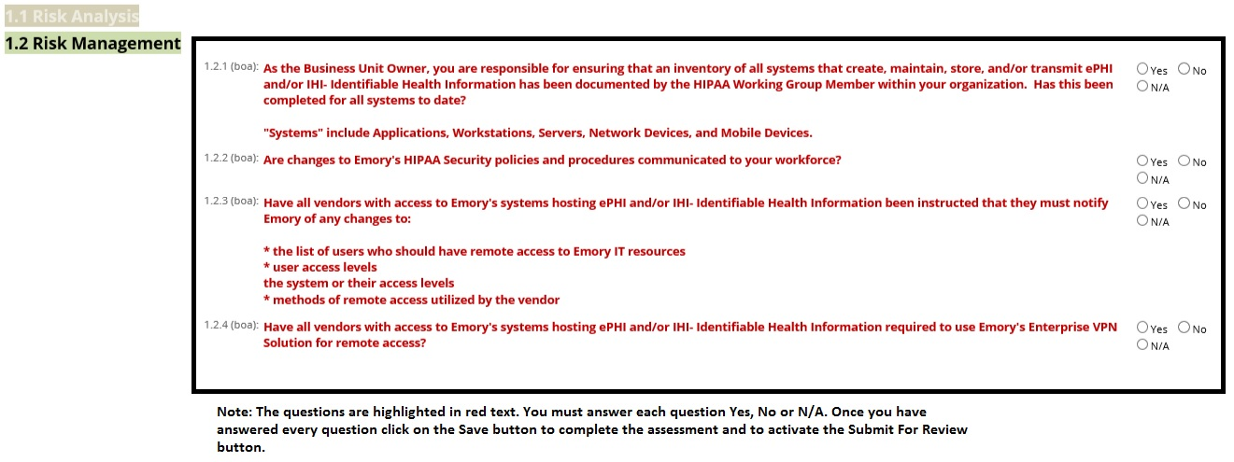

Once all the questions are answered, click SAVE button, then Submit For Review button.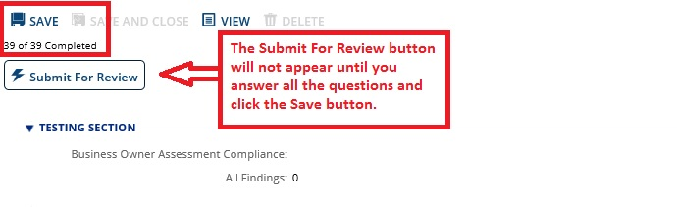

Once the assessment is submitted, you will no longer see this assessment listed in the Outstanding Assessment dashboard on the Compliance To Do List tab, but you will still see it in the All Available Assessment dashboard on the Compliance Overview tab in the Submitted status.

