Archer GRC Tool- Create Exception Request for Findings

Once all findings have an appropriate owner, a remediation plan to address each finding need to be created. In some cases, it’s not feasible to address the findings and an exception request can be created instead. Unlike Remediation Plans, Exception Request may only include one Finding.

Open the Finding record from the Compliance To Do List and click on the Accept Risk button.
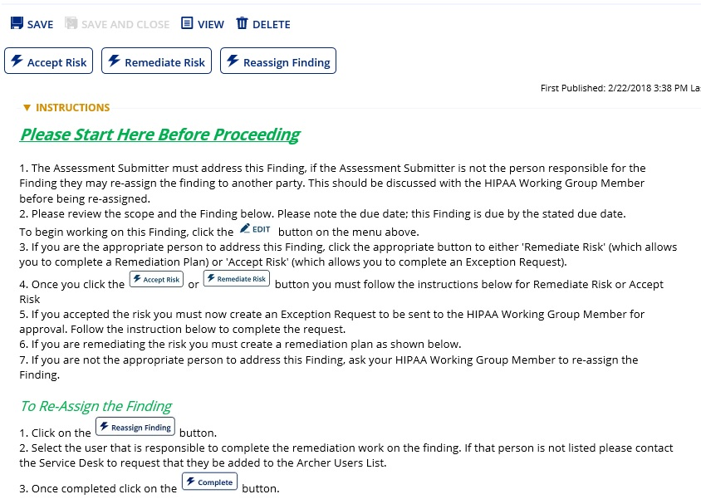

Once you have clicked on the Accept Risk button, scroll down to the Exception Request section and click the Add New button.
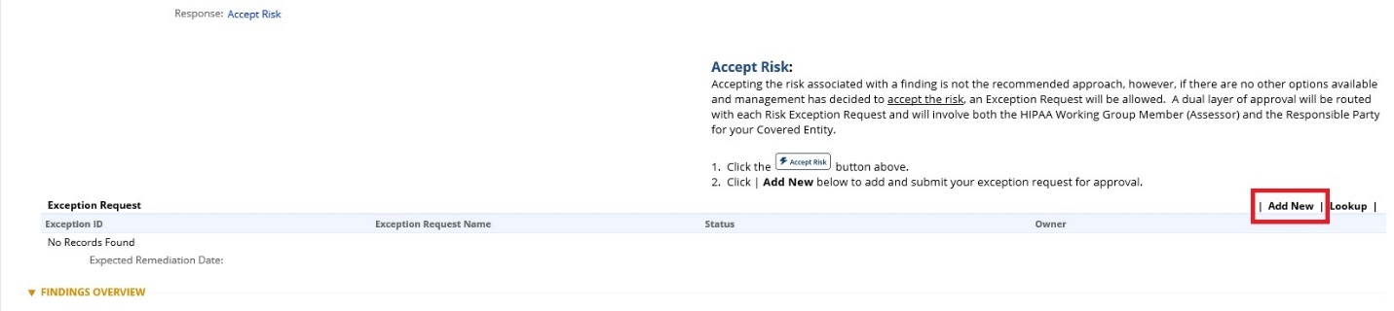

Fill out all required sections of the new record screen. Please be as detailed as possible since this will be retained as a reference for anyone interested in the risk exception. You should also discuss this request with all parties involved before submitting.
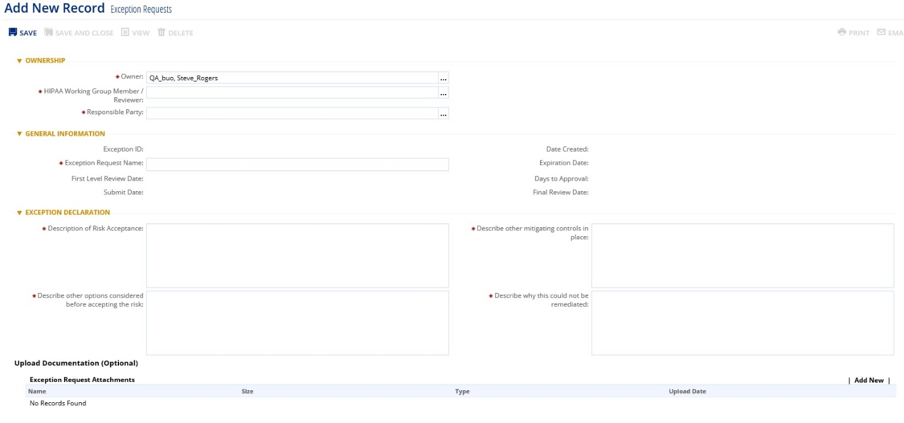

Once you have completed all sections, click on the Save button and then the Submit for Review button will appear. The HWGM/Reviewer will be notified by email that an Exception Request has been submitted for review.
