Introduction to Archer GRC Tool
Archer GRC tool can be accessed via http://archer.service.emory.edu/ using any web browser such as Microsoft Internet Explorer, Microsoft Edge, Apple Safari, Mozilla Firefox, Google Chrome.

The link will re-direct you to Emory Shibboleth Authentication page where you enter your network ID and Password and Click LOGIN button
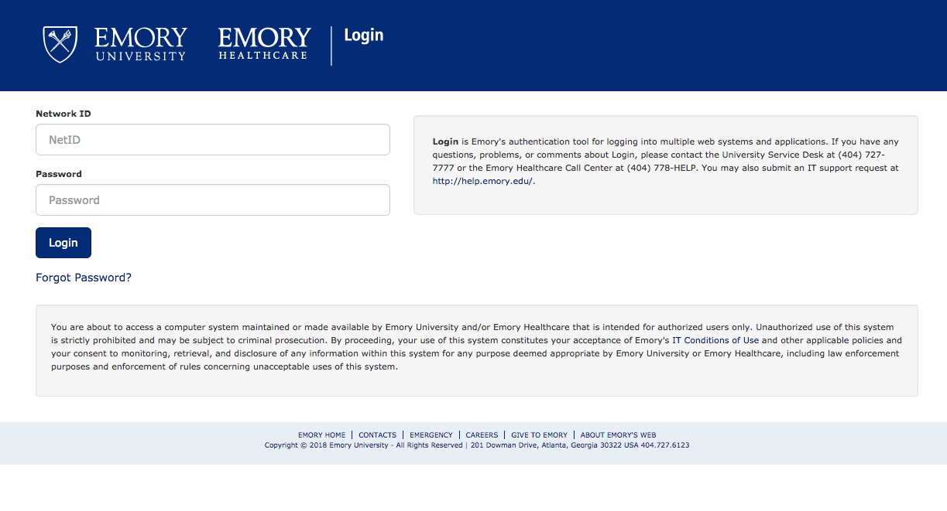

Upon successful login, you should see Archer GRC tool with top row tabs to navigate within the tool
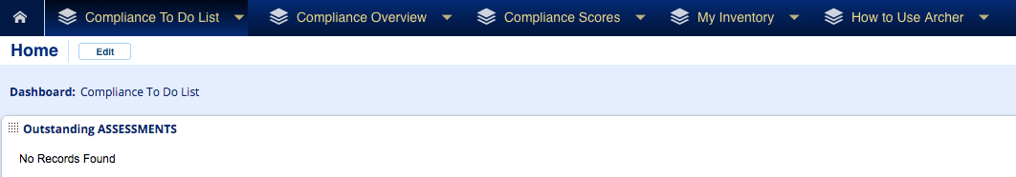

By default, you land onto the Compliance To Do List tab, which is a summary of all the Outstanding Risk Assessments, Findings, Exceptions Requests and Remediation Plans assigned to you as an Archer user.

These tasks are waiting for your completion. You can start the assessment/review process directly from this tab, by clicking on the title of the task.

If you see No Records Found message, that means that you have no outstanding tasks to do at this moment.

Compliance Overview tab provides you with the summary of the All Available Risk Assessments, Findings, Exceptions Requests and Remediation Plans tasks in your area of responsibility and their status.

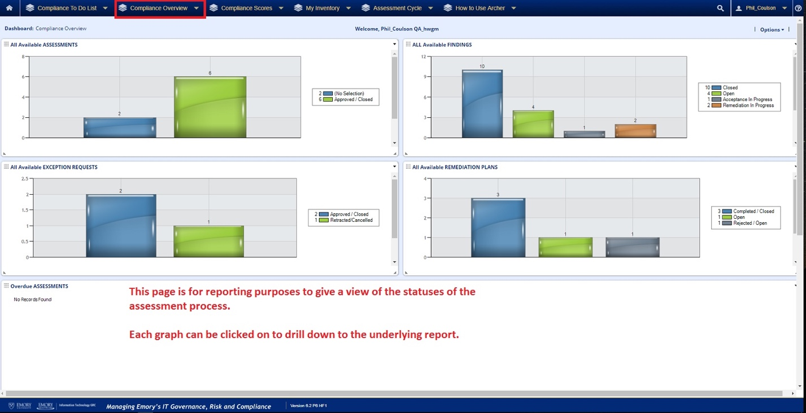

Compliance Scores tab provides you with the calculated compliance scores. Every Archer user is able to see the overall Emory and the overall Divisions within Emory compliance scores.

Business Unit Compliance score is restricted so each Archer user only sees the scores for the Business Unit the user belongs to or has a responsibility for. If you are responsible for more than one Business Unit, you will see compliance scores for each Business Unit and how they compare.

Products and Services score is also restricted so each Archer user only sees the scores for the Products and Services within the Business Unit you belong to or are responsible for. If you are responsible for multiple Products and Services, you will see compliance scores for multiple Products and Services and how they compare.

My Inventory tab provides a summary for all the inventory entered into Archer and allows a user to drill down to see the Division, Owners and IT related inventory within the area of responsibility.

How To Use Archer tab provides some basic explanation on what information each tab provides.

You can navigate within Archer by clicking on the title of each tab.

